IdeationPhase

DefinetheProblemStatements

|  |  |
| --- | --- |
| Date | 24july 2025 |
| TeamID | PNT2025TMID09231 |
| ProjectName | VisualizingHousingMarketTrends:AnAnalysis of Sale Prices and Features using Tableau |
| MaximumMarks | 2Marks |

**CustomerProblemStatementTemplate:**

Create a problem statement to understand your customer's point of view. The Customer ProblemStatement template helps youfocus on what matters tocreate experiences people will love.

A well-articulated customer problem statement allows you and your team to find the ideal solution for the challenges your customers face. Throughout the process, you’ll also be able to empathize with your customers, which helps you better understand how they perceive your product or service.

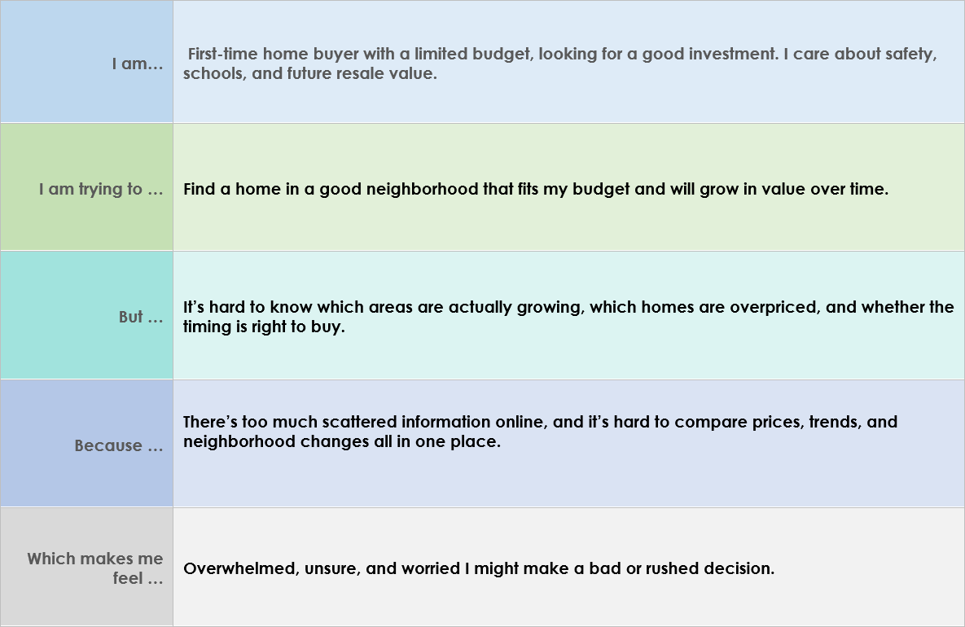

Reference:<https://miro.com/templates/customer-problem-statement/>

**Example:**

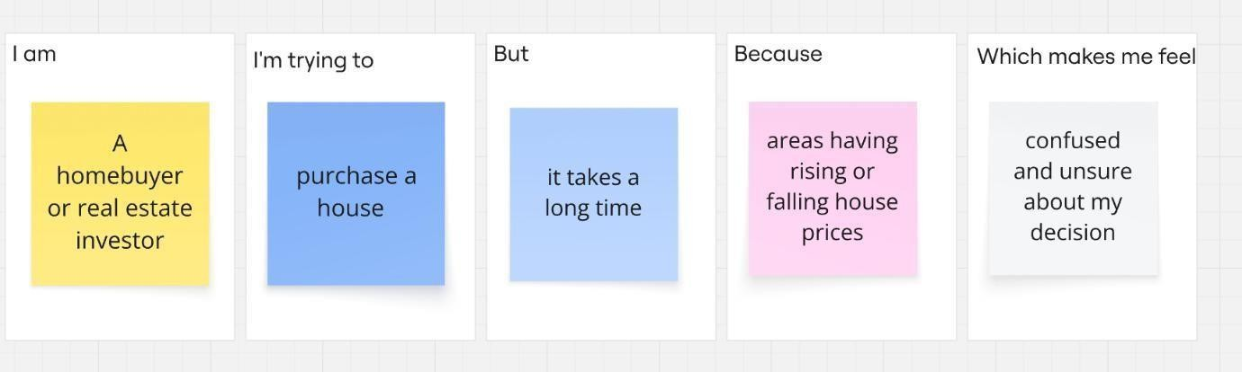

|  |  |  |  |  |  |
| --- | --- | --- | --- | --- | --- |
| **Problem Statement(PS)** | **I am (Customer)** | **I’mtryingto** | **But** | **Because** | **Whichmakesme feel** |
| PS-1 | homebuyer | Buyahouse | Selecting besthouse is challenging | Housepricesare rising or falling | Confusedand Unsure |
| PS-2 | Realestate investor | Identify best neighbourhood | Identifying improving areasis  difficult | Don’t know a clear way to compareareas | Worriedand stressed |